

Cook Islands Police Service

GOVERNMENT OF THE COOK ISLANDS

# POSITION SUMMARY

|  |  |
| --- | --- |
| **Job Title:** | Drivers License Officer |
| **Division / Unit:** | Corporate Services |
| **Responsible To:** | Finance Manager |
| **Responsible For:** | No Staff |
| **Job Purpose:** | The role of the driver’s license officer is coordinating and assisting with sustainable driver’s license initiatives, providing support for Technology, purchasing module and users, monitoring internal driver’s license systems, supporting, driver’s license projects within Cook Islands Police Service. Providing driver’s license advice to staff, negotiating new supply agreements and renegotiating existing supply agreements. |
| **Job Classification:** | Function: Leadership, Technical and Service delivery  Job Band: C  Jobwise Code: |
| **Date updated:** | September 2019 |

## AGENCY Vision

### **Values**

|  |  |
| --- | --- |
| **Courage and integrity** | We will uphold the laws and maintain the security of our nation without fear or favour, malice or ill will. |
| **Teamwork** | We will work together and respond positively to our customers. |
| **Respect** | We will respect our people and those we serve |
| **Professionalism** | We will build the knowledge and skills of our people, maintain the highest standard of discipline and apply best practice at all times. |
| **Innovation** | We will apply innovative systems and tools to enhance the delivery of quality policing service. |

ORGANISATIONAL STAFFING STRUCTURE

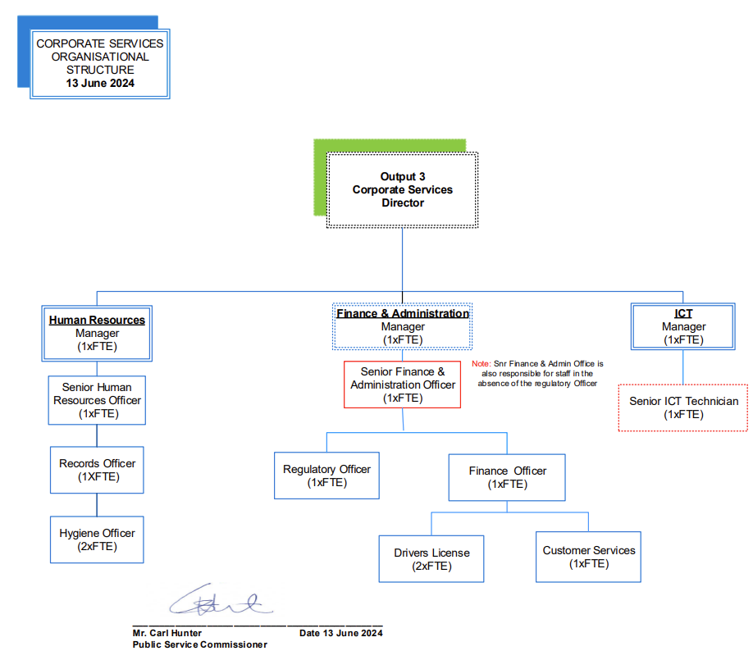

## KEY RESULT AREAS (KRA’s)/Outputs

|  |  |
| --- | --- |
| **KRAs for this position (maximum of 6)** | **Key Performance Indicators *(use SMART principles)*** |
| **KRA 1 Common requirements**   * Contribute to the development and implementation of driver’s license/financial policies and procedures for the Cook Islands Police Service in accordance with MFEM, PSC, PERCA, and Audit requirements and applicable accounting standards. * Assist Regulatory officer with reporting timely advice and financial information to the Finance Manager when requested, and when there are changes in Cook Islands Police Service operations or applicable legislation, regulations, and government policy. * Provide key driver’s license support and input into Cook Islands Police Service wide planning and operational processes. * Provide regular driver’s license forecasts and financial analysis. * Assist regulatory team to facilitate the provision of advice to government MFEM, AUDIT, PSC, in relation to Cook Islands Police Service finances. | * Cook Islands Police Service driver’s license financial policies and procedures updated and consistent with legislative and regulatory requirements, and best practices. * Accurate advice and driver’s license financial information is provided within agreed timeframes |
| **KRA 2 Service Delivery**   * Support Regulatory and Finance team in the development and implementation of innovative and sustainable driver’s license guidelines, procedures and policy. * Identify opportunities for new and integrated supply agreeements. * Gain economic savings and increased service levels from suppliers. * Development of Key Performance indicators for new and existing suppliers and monitoring of these. * Monitor internal driver’s license systems and processes and ensure that compliance is achieved across the organisation. * Undertake, complete and assist in specific driver’s license projects and provide ongoing monitoring as required including working with budget managers throughout Businessl Plan processes. * Provide staff with training on Cook Islands Police Service driver’s license systems and processes to a knowledge level relevant to their position. * Undertake any other relevant duties as directed by the Finance Manager or Director Corporate. | * Monitor supplier agreements through key performance indicators and report on achievements. * Assist staff with queries and problems with driver’s license systems and processes, and address/resolve any non-compliance issues. * Driver’s License projects are completed in an accurate and timely manner with project objectives achieved. * Existing staff have a good working knowledge of our driver’s license procedures and systems and new staff are inducted appropriately. * Any other duties are completed in a professional and timely manner to appropriate standards. |
| **KRA 3 Managing People**   * Provide excellent customer service and ensuring that a professional manner is maintained with customers at all times. * Developing and maintaining close working relationships with internal and external contacts as appropriate. * Acting as a representative for Cook Islands Police Service at appropriate Government conferences and seminars, driver’s license groups and other events held. | * Queries are dealt with in a professional and courteous manner. * Effective, professional relationships are developed and maintained with internal external contacts. * Professional image is conveyed in public forums. |
| **KRA 4 Managing Service**   * Promote the implementation of the Corporate Culture Statement, Leadership Model and Health and Safety Systems. * Recognises individual responsibility for Workplace Health and Safety. * Meet the statutory responsibilities detailed in the Police Act 2012, Code of Conduct Policy & Procedure standard. | * Corporate responsiblities are undertaken and completed accurately, meeting specified standards and within agreed timeframes. * Hazards are identified and all incidents and accidents are reported. * Participating in any wellness programmes, such as stress management training and health monitoring. * Council records are created and maintained in corporate information systems, meeting specified information management standards. |
| **KRA 5 – Key Tasks for this Unit only**   * Assist Finance team with all financial enquiries under the MFEM, PERCA, and PSC Act. * Ensure delivery of financial services in the receipting and payment of any accounts is in accordance with the MFEM Government financial policy. * Attend to all customer requests and enquiries both locally and internationally including email and telephone enquiries CIB on behalf of their clients. * Ensuring delivery of administrative financial services to staff and general public within performance management agreements in consultation with the Finance Manager. | * Timely respond to enquiries (including phone and email) within set parameters. * Customer satisfaction.   Performance management agreement targets are met. |
| **KRA 6 – Systems Development**   * Implement IT systems that improve financial management and expand Cook Islands Police Service capabilities and efficiencies (e.g. implementing EFTPOS and online payment methods). | * IT solutions are identified, scoped, and implemented where approved by the Director and where resources are available. |

## Work Complexity

**Complexity**

|  |  |
| --- | --- |
| *Indicate most challenging problem solving duties typically undertaken (3-4 examples):* | |
| 1 | Development and review of driver’s license guidelines, procedures and systems. |
| 2 | Negotiation of supplier agreements resulting in economic savings and increased service levels. |
| 3 | Convey information and ideas through a variety of media types to individuals or groups in a manner that engages the audience and helps them understand and retain the key messages. |
| 4 | Use their interpersonal syles and methods to inspire and guide others towards positive changes in behaviour. |

## Authority

Authority levels expressed in terms of routine expenditure, granting loans, and recruiting and dismissing staff. (*Explain the authority if any*)

|  |  |
| --- | --- |
| **Financial** | No Authorisaton |
| **Staff** | No staff |
| **Contractual** | No Authorisation |

## Functional Relationships

The requirement for human relations skills in dealing with other personnel and external contacts. *(List the external and internal types of functional relationships)*

|  |  |  |  |  |
| --- | --- | --- | --- | --- |
| Internal  Finance Manager  Outer Islands Police | **Heavy**: Providing support, advice, analysis, and reports.  Developing budget, annual reports, and all police special operations including maritime operations.  **Medium:**  Coordinates payments, receipting and banking of driver’s license. | External  Business Company/Suppliers | **Medium**:  Receipting and payment of restocking of police resources.  . |  |

## QualificationS (or equivalent level of learning)

Level of education required to perform the functions of the position. This combines formal and informal levels of training and education.

|  |  |
| --- | --- |
| **Essential: (least qualification to be competent)** | **Desirable: (other qualifications for job)** |
| * NZQA Level 3 - Certificate | * Tertiary qualification in a related field |

## Experience

The length of practical experience and nature of specialist, operational, business support or managerial familiarity required. This experience is in addition to formal education.

|  |  |
| --- | --- |
| **Essential: (least number of years to be competent)** | **Desirable: (target number of years you are looking for)** |
| 3-5 years of work experience in advanced driver’s license role, five of which involves finance and business engagement roles. | 5-7 years of work experience in advanced accounting or financial role, five of which involves finance and business engagement roles. |

## Key Skills /AttributeS/JOB Specific Competencies

|  |  |
| --- | --- |
| **Level of ability required for the job** |  |
| **Advanced** | * Ability to write policies and procedures * Strong negotiation skills * Well developed oral and written communication skills * Project and time management ability |
| **Working** | * Sound knowledge of finance procedures and systems * A good understanding of contracts * A good level of computer ability |
| **Awareness** | * Community cultural and political awareness * Ability to proof read documents for quality |

## CHANGE to JOB description

Changes to the Job description may be made from time to time in response to the changing nature of the Agency work environment - including technological or statutory changes.

**Approved:**

HoM/Manager Date

Employee Date